**RESPONSIVEFURNITUREWEBSITE**



A

Human Computer Interface Course Project Report

in partial fulfilment of the degree

Bachelor of Technology

in

Computer Science & Artificial Intelligence

By

ARSHA VARDHINI 2303A51600

NEHA FARIYAL 2303A51598

VARSHITHA 2303A51927

Under the guidance of

FAIZA IRAM

Assistant Professor

Submitted to

School of Computer Science and Artificial Intelligent





**DEPARTMENT OF COMPUTER SCIENCE & ENGINEERING**

**CERTIFICATE**

This is to certify that the Human Computer Interface Report entitled "RESPONSIVEFURNITUREWEBSITE" is a record of bonafide work carried out by the student , ARSHA VARDHINI , NEHA FARIYAL, VARSHITHA bearing RollNo(s).

2303A51600,2303A1598,2303A51927 during the Academic year 2023-2024 in partial fulfillment of the award of the degree of Bachelor of Technology in Computer Science & Engineering by the SR University, Ananthasagar, Hanamkonda.

**Lab In-charge Head ofthe Department**

FAIZA IRAM **Dr. M. Sheshikala**

Asst.Professor Dept of CSE, Assoc. Prof. & HOD (CSE),

SR Engineering College, SR Engineering College,

Ananthasagar, Warangal. Ananthasagar, Warangal.

**ACKNOWLEDGMENT**

We owe an enormous debt of gratitude to our project guide**Faiza Iram**, Assistant

Professor as well as Head of the CSE Department **Dr. M. Sheshikala**,Associate Professor for

guidingus from the beginning through the end of the Project with their intellectual advices

and insightfulsuggestions. We truly value their consistent feedback on our progress, which

was always constructiveand encoraging and ultimately drove us to the right direction.

We wish to take this opportunity to express our sincere gratitude and deep sense of respect to

our beloved Vice Chancellor, **Prof. Deepak Garg**, for his continuous support and guidance to

completethis project in the institute.Finally, we express our thanks to all the teaching and

non-teaching staff of the department fortheir suggestions and timely support.

**TABLE OF CONTENT**

|  |  |
| --- | --- |
| **TOPIC** | **PAGE NO** |
| Abstract | 5 |
| Objective | 6 |
| Existing System | 7 |
| Proposed System | 8 |
| Software and Hardware requirements | 9 |
| Elements used in the project | 10 |
| Implementation | 11-17 |
| Design | 18-22 |
| Conclusion | 22-23 |

**ABSTRACT**

Our gym website offers a comprehensive platform designed to inspire and support fitness enthusiasts in achieving their health and wellness goals. The site provides an intuitive user experience with features such as online class booking, personalized workout plans, virtual training sessions, and access to expert advice from certified trainers. Members can track their progress, explore a library of workout routines and nutritional tips, and engage with a vibrant fitness community through forums and challenges. Whether you're a beginner or an experienced athlete, our online platform empowers you to take control of your fitness journey from anywhere.

**OBJECTIVE**

1. **Enhanced Accessibility**
   * Provide users with a seamless way to explore gym services, book sessions, and access fitness resources anytime, anywhere.
2. **Personalized Fitness Journey**
   * Offer tailored workout plans, progress tracking tools, and nutritional advice to meet individual health goals and preferences.
3. **Community Building**
   * Foster a supportive fitness community through interactive forums, challenges, and social features that encourage collaboration and motivation.
4. **Virtual Training Integration**
   * Deliver high-quality virtual training sessions and tutorials to allow users to train from home or on the go.
5. **Educational Resources**
   * Educate users about fitness techniques, injury prevention, and wellness tips through blog articles, video tutorials, and expert guidance.
6. **Membership Management**
   * Streamline membership processes, including sign-ups, renewals, and payment management, to enhance convenience for users.
7. **Encouragement of Healthy Lifestyles**
   * Promote long-term health and well-being by providing tools and inspiration for sustainable fitness habits.

.

**EXISTING SYSTEM:**

1. Limited Personalization

• Many existing websites lack advanced algorithms to create truly customized workout plans or nutrition advice, leading to a generic experience for users.

2. Poor User Interface (UI) and Experience (UX)

• Some gym websites have outdated designs, complicated navigation, or slow loading times, discouraging users from engaging further.

3. Lack of Virtual Training Options

• Not all websites offer high-quality virtual classes or live training sessions, which are crucial for remote users or those with busy schedules.

4. Inefficient Progress Tracking

• Existing websites often provide limited tools for tracking progress, such as workout history, weight management, or fitness analytics.

5. Insufficient Community Engagement

• Many websites fail to foster a sense of community, offering minimal interaction between members, such as forums, challenges, or motivational tools.

6. Inadequate Mobile Compatibility

• Some gym websites are not optimized for mobile devices, making them difficult to use for users on the go.

7. Limited Integration with Fitness Devices

• A lack of integration with wearables or fitness apps (like Fitbit or Apple Health) reduces the website's utility for tracking and syncing fitness data.

8. Content Gaps

• Some sites do not provide enough educational content, such as workout tutorials, injury prevention tips, or dietary advice, leaving users to seek information elsewhere.

9. Poor Customer Support

• Users often face delayed responses or no support for technical issues, booking problems, or general inquiries.

10. Lack of Motivation Tools

**PROPOSED SYSTEM:**

**1. Premium Membership Packages**

**• Offer tiered premium plans with benefits such as personalized workout plans, exclusive access to virtual classes, and priority trainer support.**

**2. Healthy Tips and Insights**

**• Include a dedicated section for regularly updated health tips, covering nutrition, mental well-being, hydration, and recovery techniques.**

**3. Equipment Guidance**

**• Provide step-by-step guides and video tutorials for gym equipment usage, including safety tips and workout recommendations.**

**4. Trainer Interaction**

**• Enable direct communication with certified trainers for personalized fitness advice, progress reviews, and Q&A sessions.**

**5. Progress Tracking Tools**

**• Integrate tools to monitor workout progress, weight changes, and fitness milestones, with visual charts and motivational feedback.**

**6. Community Engagement**

**• Create forums, group challenges, and social spaces to foster a supportive and interactive fitness community.**

**7. On-Demand Virtual Training**

**• Offer high-quality virtual training sessions, including live classes and pre-recorded workouts, accessible from any device.**

**8. Mobile Compatibility**

**• Ensure the website is fully responsive and optimized for mobile devices, offering seamless navigation and functionality on the go.**

**9. Integrated Fitness Ecosystem**

**• Sync the website with fitness devices and apps (e.g., Fitbit, Apple Health) to provide a unified platform for tracking and analyzing health data.**

**10. Robust Customer Support**

**• Include 24/7 customer support via chat, email, or phone to address membership queries, booking issues, and technical assistance promptly.**

**SOFTWARE REQUIREMENTS &**

**TECHNICAL REQUIREMENTS:**

* **HTML (HyperText Markup Language)**
* **CSS (Cascading Style Sheets)**
* **JavaScript :**Purpose

**HARDWARE REQUIREMENTS:**

1. **Web Browser :**Purpose*: Required for testing the website across different browsers (Chrome, Firefox, Safari, Edge).
2. **Code Editor/IDE :**Examples: Visual Studio Code, Sublime Text, or Atom for writing

and managing frontend code. These editors offer syntax highlighting, code suggestions, and integration with version control systems.

1. **Graphics Software (Optional for Asset Creation):**Examples: Adobe Photoshop, Figma, Sketch for creating and editing product images, logos, and other visual elements.

Purpose: Helps in designing the user interface (UI) and visual assets for the website.

1. **Testing Devices**:Purpose: Devices (smartphones, tablets, desktops) to test how the website looks and behaves on various screen sizes.

Specifications: Various devices with different screen resolutions to ensure proper responsiveness.

**ELEMENTS USED IN THE PROJECT:**

* **User Interface (UI):**The user interface provides the front-end components for interaction. It includes intuitive navigation menus, product catalogs, and visual elements like sliders or banners for a seamless user experience. Features like search bars, filtering options, and shopping cart access are essential.
* **Database:**A database stores all crucial information, such as product details (e.g., furniture categories, sizes, colors), user profiles, order history, inventory levels, and promotional offers. It ensures efficient data storage and retrieval for the website.
* **Product Catalog System:**This module allows users to browse and view products, with detailed pages for individual items. It includes options for sorting, filtering, and searching for products based on user preferences (e.g., price range, color, or material).
* **Shopping and Ordering System:**

Enables customers to add products to a cart, customize orders (e.g., selecting fabric or size), and proceed to payment. Features include secure payment gateways, real-time cart updates, and order summaries.

* **Mobile and Online Responsiveness:**  
  The site is fully responsive, providing a seamless browsing and shopping experience across all devices, including mobile phones, tablets, and desktops.
* **Security:**

Critical features include user authentication, data encryption, secure payment systems.

**IMPLEMENTATION:**

**CODE:**

**//Home page html code :**

<!DOCTYPE html>

<html lang="en">

<head>

<meta charset="UTF-8">

<meta name="viewport" content="width=device-width, initial-scale=1.0">

<title>HEAVY METTLE | Home</title>

<link rel="stylesheet" href="styles.css">

</head>

<body>

<header>

<h1>HEAVY METTLE</h1>

<nav>

<a href="index.html">Home</a>

<a href="about.html">About Us</a>

<a href="classes.html">Classes</a>

<a href="trainers.html">Trainers</a>

<a href="facilities.html">Facilities</a>

<a href="contact.html">Contact</a>

<a href="registration.html">Join Us</a>

<a href="Diet Plan.html">diet plan</a>

</nav>

</header>

<main>

<h2>Welcome to HEAVY METTLE</h2>

<img src="[https://www.shutterstock.com/image-vector/people-gym-athletes-group-doing-260nw-1458527921.jpg"alt="pic](https://www.shutterstock.com/image-vector/people-gym-athletes-group-doing-260nw-1458527921.jpg%22alt=%22pic)"/>

<p> Your journey to a healthier lifestyle starts here. Join us and become part of our fitness community.</p> </main> <footer> <p>Contact us: [info@Heavymettle.com](mailto:info@Heavymettle.com) | Phone: (555) 123-4567</p>

</footer>

</body>

</html>

<title>HEAVY METTLE | About

Us</title>

<link rel="stylesheet" href="styles.css">

</head>

<body>

<header> <h1>About Us</h1>

<nav>

<a href="index.html">Home</a>

<a href="about.html">About Us</a>

<a href="classes.html">Classes</a>

<a href="trainers.html">Trainers</a>

<a href="facilities.html">Facilities</a>

<a href="contact.html">Contact</a>

<a href="registration.html">Join Us</a>

<a href="Diet Plan.html">diet plan</a>

</nav>

<h2>Our Story</h2>

<img src="discount (1).png"alt="pic"/>

<p>HEAVY METTLE is dedicated to helping you achieve your fitness goals. With expert trainers and state-of-the-art facilities, we offer a welcoming community that supports your journey to a healthier life.</p> </main>

<footer>

<p>Contact us: [info@Heavymettle.com](mailto:info@Heavymettle.com) | Phone: (555) 123-4567</p>

</footer>

<title>HEAVY METTLE | Classes</title>

<link rel="stylesheet" href="styles.css">

<h1>Our Classes</h1>

<nav>

<a href="index.html">Home</a>

<a href="about.html">About Us</a>

<a href="classes.html">Classes</a>

<a href="trainers.html">Trainers</a>

<a href="facilities.html">Facilities</a>

\ <a href="contact.html">Contact</a>

<a href="registration.html">Join Us</a>

<a href="Diet Plan.html">diet plan</a>

</nav>

</header>

<main>

<h2>Classes We Offer</h2>

<p>We offer a variety of classes including yoga, Pilates, HIIT, spinning, and more. Each class is designed to help you reach your fitness goals in a supportive group setting.</p>

<p>

<img src="<https://img.freepik.com/free-vector/set-yoga-postures_1308-119286.jpg>" alt="Yoga Classes" style="width: 100%; max-width: 600px;"/>

<strong>Yoga Classes</strong>

<br>

Offer a tranquil space where members can practice flexibility, balance, and mental focus. Yoga sessions cater to all skill levels, from beginners to advanced practitioners, helping with relaxation, stress relief, and overall wellness. </p> <p>

<img src="<https://i.pinimg.com/736x/fe/8f/98/fe8f98d4b42bb7c8a071c3170a1adecd.jpg>" alt="Cardio Workouts" style="width: 100%; max-width: 600px;"/> <strong>Cardio Workouts</strong>

<br>

Feature a range of high-energy options that boost heart health, endurance, and calorie burn. Our cardio equipment includes treadmills, stationary bikes, and rowing machines, designed to suit all fitness levels and support various training goals, from weight loss to endurance building. </p> <h3>Watch Action-Packed Fitness Preview</h3> <p>Click the button below to watch a high-energy preview of our action classes.

</p>

<a href="<https://youtu.be/m756Gz8de4M?si=CvduloFzItmD352t>" target="_blank" class="action-button">Watch Now</a> <p>Click the button below to watch a high-energy preview of our action classes.</p>

<a href="<https://youtu.be/dj03_VDetdw?si=GGJ7h9nvAbZRrQD6>" target="_blank" class="action-button">

Watch Now</a>

</main>

<footer>

<p>Contact us: [info@Heavymettle.com](mailto:info@Heavymettle.com) | Phone: (555) 123-4567</p>

<!DOCTYPE html>

<html lang="en">

<head>

<meta charset="UTF-8">

<meta name="viewport" content="width=device-width, initial-scale=1.0">

<title>HEAVY METTLE | Thank You</title>

<link rel="stylesheet" href="styles.css">

<script src="script.js" defer></script>

</head>

<body>

<header>

<h1>Thank You for Joining HEAVY METTLE !</h1>

<nav>

<a href="index.html">Home</a>

<a href="about.html">About Us</a> <a href="classes.html">Classes</a> <a href="trainers.html">Trainers</a> <a href="facilities.html">Facilities</a>

<a href="contact.html">Contact</a>

<a href="registration.html">Join Us</a>

<a href="Diet Plan.html">diet plan</a>

</nav>

</header>

<main>

<h2>Registration Successful!</h2>

<p>Thank you for registering with Heavymettle! We’re excited to have you as a member and look forward to supporting you on your fitness journey.</p>

<p>Check your email for more details, including membership benefits and our class schedules. If you have any questions, feel free to <a href="contact.html">contact us</a>.</p> <p>Welcome to the Heavymettle community!</p> </main> <footer> <p>Contact us: [info@Heavymettle.com](mailto:info@Heavymettle.com)| Phone: (555) 123-4567</p> </footer>

</body>

</html>

CSS:

* {

margin: 0;

padding: 0;

box-sizing: border-box;

} body

{ font-family: 'Roboto',

sans-serif; color: #444444;

line-height: 1.6;

background-color: #f4f4f4;

}

/* Header */

Header

{

background-color: #1e1e1e;

background- color: #fff

; padding: 5em 2em; text-align:

center; box-shadow: 0 4px 10px rgba(0, 0, 0, 0.3); }

header h1 { font-size: 3.5em;

font-weight: 700;

letter-spacing: 2px; margin-bottom: 0.5em; text-transform: uppercase;

} nav { margin-top: 2em; }

nav a { color: #fff; text-decoration: none; margin: 0 20px;

font-size: 1.2em;

font-weight: 500;

transition: color 0.3s ease;

} nav a:hover { color: #00aaff; }

main { padding: 3em 2em; max-width: 1000px; margin: 40px auto;

background-color: #fff; border-radius: 10px; box-shadow: 0 6px 15px rgba(0, 0, 0, 0.1)

; text-align: center; }

main h2 { color: #333

; margin-bottom: 20px; font-size: 2.5em;

font-weight: 700; text-transform: uppercase;

letter-spacing: 2px; }

main p { color: #555;

font-size: 1.2em; line-height: 1.8;

margin-bottom: 30px; text-align: justify;

} main ul { color: #555; font-size: 1.2em;

line-height: 1.8; margin-bottom: 30px; text-align: justify; }

form { display: flex; flex-direction: column;

align-items: center; background: #f9f9f9;

padding: 30px; border-radius: 10px

; box-shadow: 0 4px 8px rgba(0, 0, 0, 0.2); }

form input, form select,

form button { width: 100%; padding: 15px; margin: 12px 0; font-size: 1.1em; border-radius: 8px;

border: 2px solid #ddd; background-color:

#fff; transition: border-color 0.1s ease, box-shadow 0.1s ease; }

form input:focus, form select:focus

{ border-color: #00aaff; box-shadow: 0 0 8px rgba(0, 170, 255, 0.5);

outline: none; } form button

{ background-color: #00aaff;

color: #fff; font-weight: 600; cursor: pointer; transition: background-color 0.1s ease; }

form button:hover { background-color: #007bb5; }

form label { font-weight: 500; color: #333; }

/* Footer */ footer

{ background-color: #333; color: #fff; text-align

: center; padding: 2.5em 1.5em; margin-top: 60px; }

footer p { font-size: 1.1em; }

.card { background-color: #ffffff; border-radius:

10px; box-shadow: 0 4px 8px rgba(0, 0, 0, 0.1); overflow: hidden; margin-bottom: 30px; transition: transform 0.1s ease, box-shadow 0.1s ease; } .card:hover { transform: translateY(-5px); box-shadow: 0 6px 12px rgba(0, 0, 0, 0.2); } .card img { width: 100%; height: 200px; object-fit: cover; }

.card-body { padding: 20px; text-align: left; } .card h3 { color: #333; font-size: 1.8em; margin-bottom: 15px; } .card p { color: #555; font-size: 1.1em; } @media (max-width: 768px)

{ header { padding: 3em 2em; }

header h1 { font-size: 2.5em; } nav a { font-size: 1.1em; margin: 0 10px; } main { padding: 2em; } form { width: 90%; } footer p { font-size: 1em; } } .action-button { display: inline-block;

padding: 10px 20px;

font-size: 16px; color: #fff; background-color: #007BFF;

text-decoration: none; border-radius:

5px; transition: background-color 0.01s; } .

action-button:hover { background-color: #0056b3; }

JS:

Function submitRegistrationForm(event) {

event.preventDefault();

const formData = {

name:

document.getElementById('name').value, email

: document.getElementById('email').value, phone: document.getElementById('phone').value, membership:

document.getElementById('membership').value, paymentMethod: document.getElementById('payment').value };

console.log("Form submitted:", formData); processPayment(formData); } function processPayment(formData)

{ alert("Processing your payment... Please wait.");

setTimeout(() => { alert("Transaction Successful! Thank you for joining HEAVY METTLE."); window.location.href = "thankyou.html"; })

; } document.addEventListener('DOMContentLoaded', () => {

const registrationForm = document.getElementById('registrationForm');

if (registrationForm)

{ registrationForm.addEventListener('submit', submitRegistrationForm);

} });

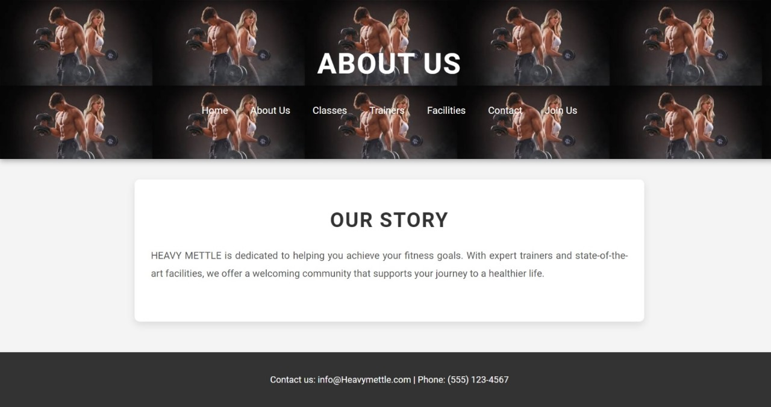

DESIGN:

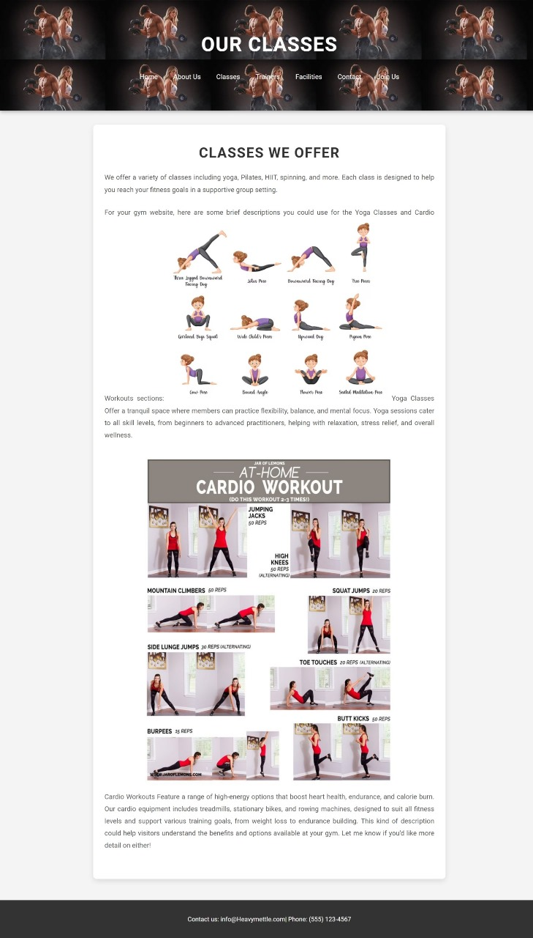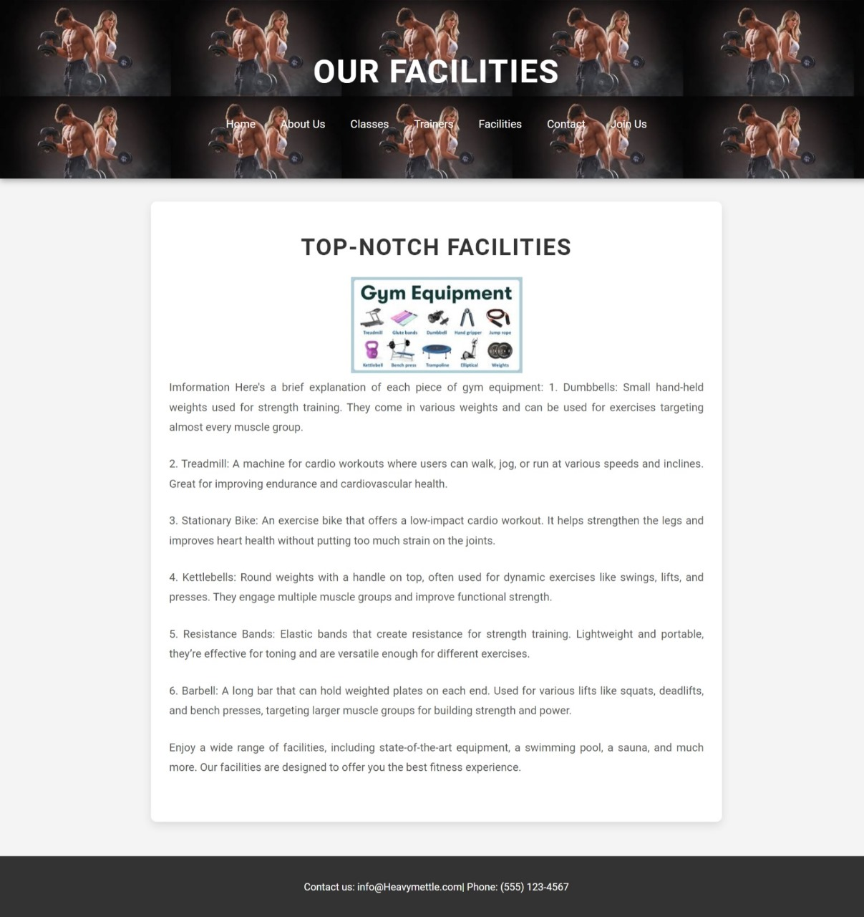

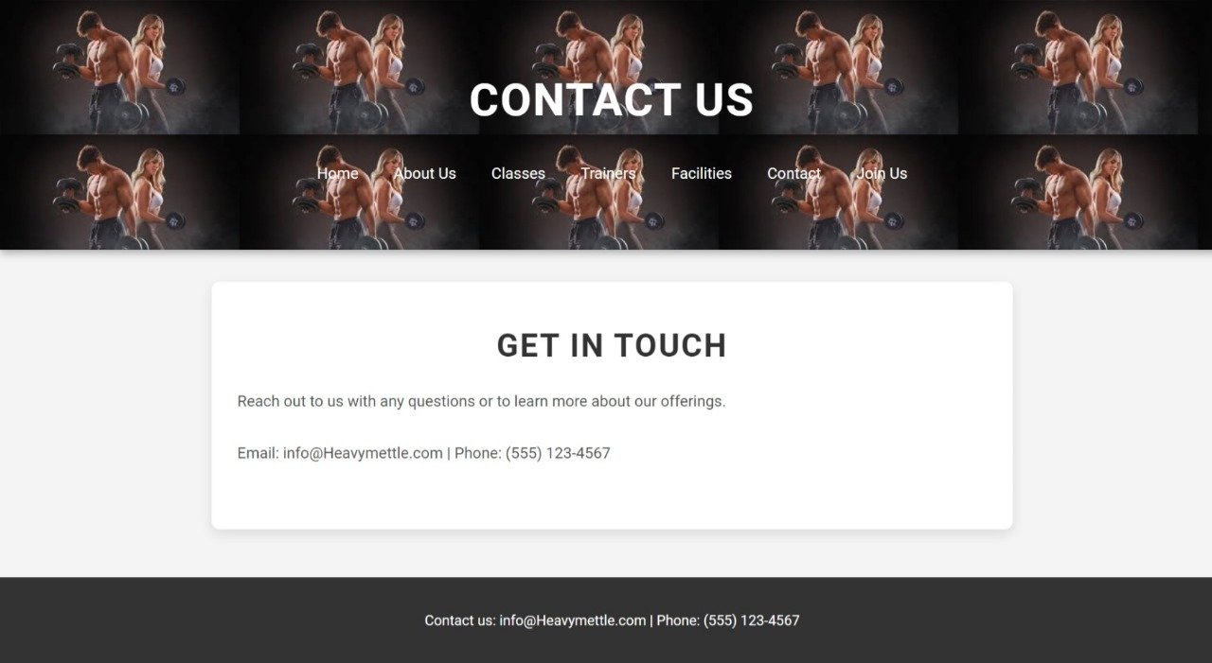

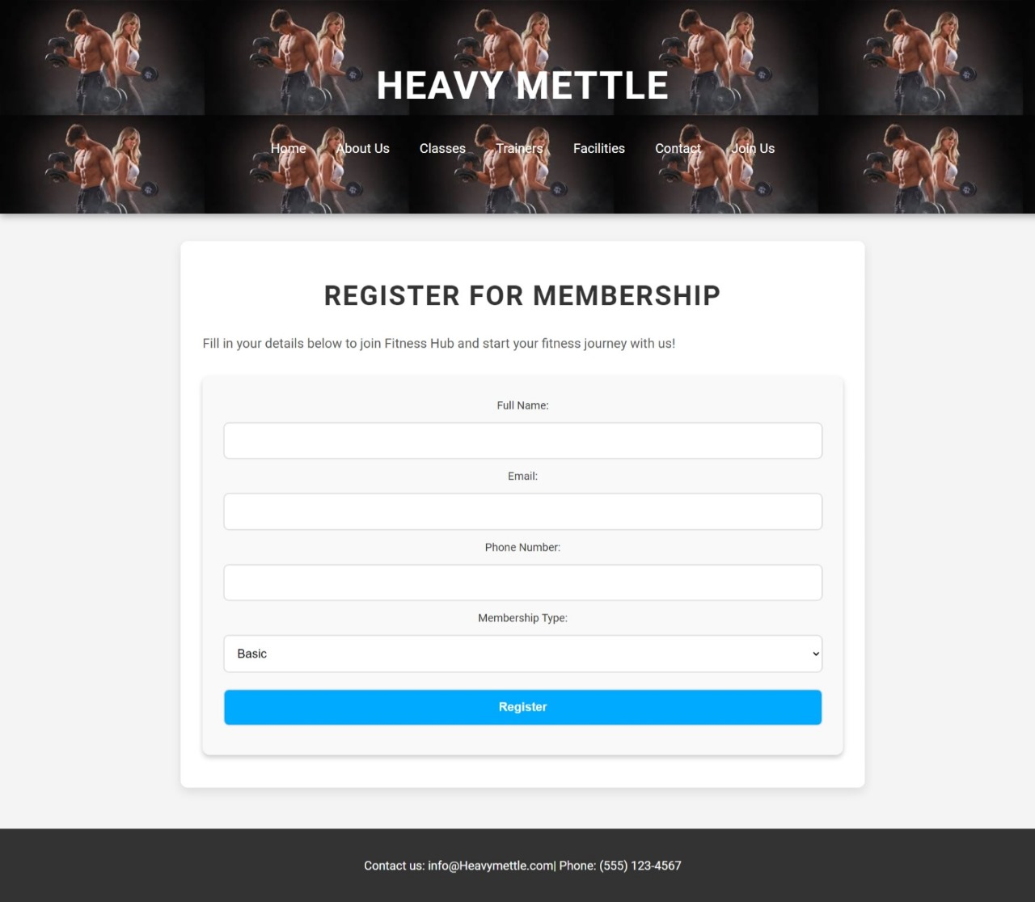

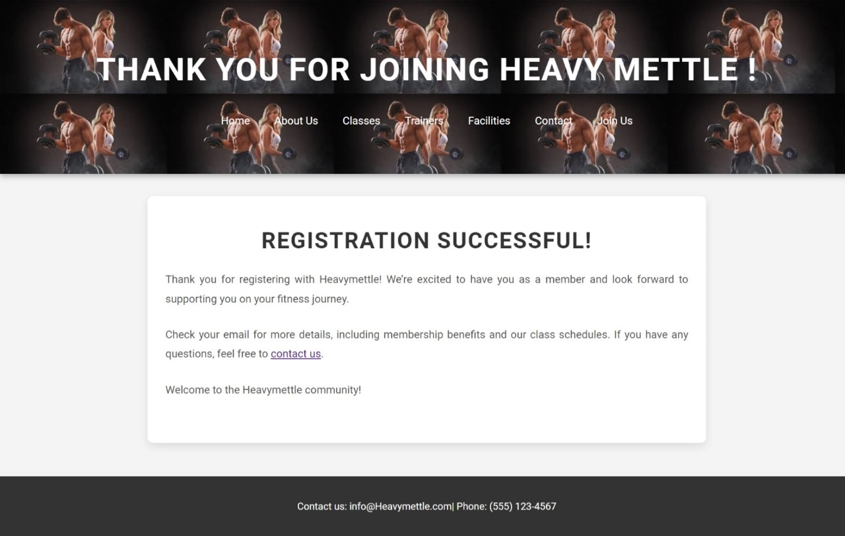

**CONCLUSION:**

The proposed gym website redefines the fitness experience by creating a centralized platform tailored to meet the diverse needs of modern users. With premium membership packages offering exclusive features, members gain access to personalized plans, priority services, and advanced tools to elevate their fitness journey. A dedicated section for healthy tips ensures users are equipped with actionable advice on nutrition, wellness, and recovery, fostering a balanced lifestyle.

The inclusion of equipment guidance, through step-by-step tutorials and safety tips, enhances user confidence, especially for beginners, while direct access to expert trainers bridges the gap between members and professional guidance. Robust progress tracking tools allow users to monitor and visualize their fitness milestones, motivating them to stay consistent.

Community engagement features, such as forums, challenges, and social interactions, create a sense of belonging, fostering motivation and collaboration among members. High-quality virtual training, combined with mobile compatibility and fitness device integration, ensures users have flexibility and accessibility, whether at home, in the gym, or on the go.

By addressing the shortcomings of existing platforms and offering 24/7 customer support, the proposed system stands out as a comprehensive and dynamic solution. It not only empowers individuals to achieve their fitness goals but also establishes a long-term commitment to health and well-being.